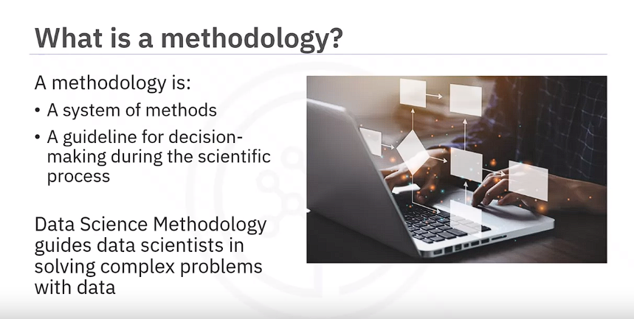

Data Science combines statistics, technology, and domain expertise to extract insights from vast data.

Based on the overview you provided, it's clear that data science methodology is a structured approach that guides data scientists through solving complex problems and making data-driven decisions**. John Rollins's contributions to data methodology have outlined a 10-stage process** that helps streamline the data science workflow. Here's a breakdown of the 10 stages and the questions associated with each stage:

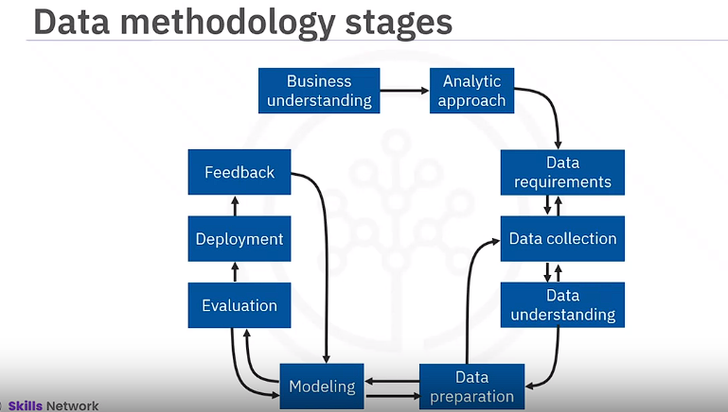

1. **Business Understanding:**
   * What is the problem that you're trying to solve?
   * How can you use data to answer the question?
2. **Analytic Approach:**
   * What approach will you take to solve the problem?
3. **Data Requirements:**
   * What data do you need to answer the question?
   * Where is the data sourced from?
   * How will you receive the data?
4. **Data Collection:**
   * Does the data you collect represent the problem to be solved?
5. **Data Understanding:**
   * What additional work is required to manipulate and work with the data?
6. **Data Preparation:**
   * How will you manipulate the data to prepare it for analysis?
7. **Modeling:**
   * What modeling techniques will you use to analyze the data?
8. **Evaluation:**
   * When you apply data visualizations, do you see answers that address the business problem?
   * Does the data model answer the initial business question, or must you adjust the data?
9. **Deployment:**
   * Can you put the model into practice?
10. **Feedback:**
    * Can you get constructive feedback from the data and the stakeholder to answer the business question?

These questions serve as checkpoints throughout the data science process, ensuring that data scientists are aligned with the problem they're solving, have the necessary data, and are effectively analyzing and interpreting results to address the business needs. Following this methodology helps in avoiding common pitfalls and ensures a structured and effective approach to solving data-driven problem

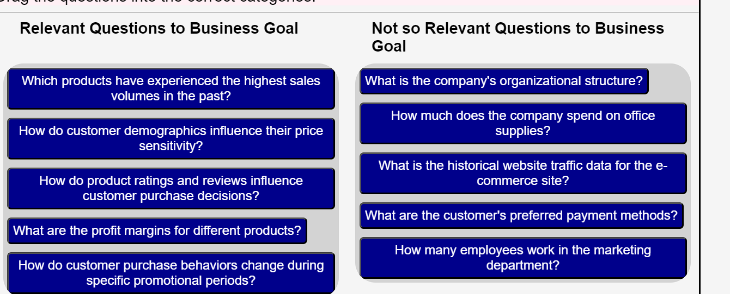

The "Business Understanding" phase in data science methodology is crucial for setting the right direction and ensuring that the analysis aligns with the organization's goals and objectives. Here's a breakdown of the key points covered in the provided text:

1. **Clarifying the Problem**: When faced with a task or problem, it's essential to seek clarification to fully understand the requirements. This includes identifying the core question to be answered and understanding the goals and objectives behind it.
2. **Understanding the Goal**: Understanding the overarching goal behind the question helps in determining the appropriate approach for analysis. It's important to align the analysis with the ultimate aim of the person or organization posing the question.
3. **Identifying Objectives**: Breaking down the goal into specific objectives helps in structuring discussions and prioritizing tasks. This step involves identifying key areas of focus that contribute to achieving the overarching goal.
4. **Engaging Stakeholders**: Involving relevant stakeholders in discussions is essential for gathering requirements, clarifying questions, and ensuring that the analysis addresses the needs of all parties involved.
5. **Case Study Example**: The provided case study illustrates the application of the "Business Understanding" phase in a real-world scenario. In this case, an American healthcare insurance provider collaborated with health care authorities and IBM data scientists to address the challenge of maximizing the use of the limited healthcare budget.
6. **Defining Goals and Objectives**: Before collecting data, the team defined clear goals and objectives, prioritizing the area of patient readmissions for review.
7. **Utilizing Decision-Tree Model**: To address the challenge, the team proposed using a decision-tree model to understand the factors contributing to patient readmissions, particularly focusing on patients with congestive heart failure.
8. **Key Business Sponsor Involvement**: The involvement of key business sponsors throughout the project was critical for setting the overall direction, providing guidance, and ensuring necessary support.
9. **Identifying Business Requirements**: Four key business requirements were identified for the model, including predicting readmission outcomes, understanding readmission risk factors, analyzing event combinations, and applying the model to new patients.
10. **Conclusion**: The "Business Understanding" phase lays the foundation for successful data analysis projects by ensuring alignment with organizational goals, clarifying requirements, and setting clear objectives for the analysis.

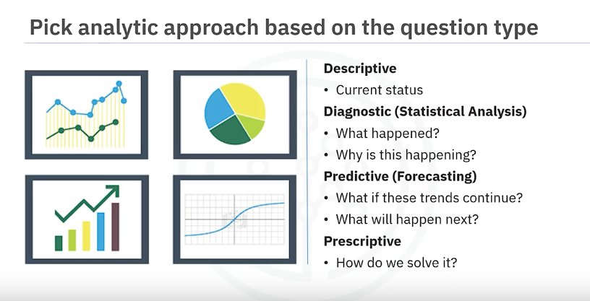

1. **Types of Analytic Approaches**:
   * **Predictive Modeling**: Used to determine probabilities of future events or actions. **Predictive models are trained on historical data to make predictions about future outcomes.**
   * **Descriptive Analysis**: Focuses on showing relationships and patterns within data. It includes techniques like **clustering to group** similar activities **based on events and preferences.**
   * **Statistical Analysis**: Applied to problems that require counting or classification, such **as yes/no answers**. Statistical methods are used to analyze and interpret data to make i**nformed decisions.**
   * **Machine Learning**: A field of study that enables computers to learn from data without being explicitly programmed. Machine learning algorithms identify relationships and trends in data to make predictions or decisions.
2. **Selecting the Analytic Approach**: Once the question is clearly defined, the appropriate analytic approach is selected based on the type of patterns or insights needed to address the question effectively.
3. **Case Study Example**: In the provided case study, a decision tree classification model was chosen as the analytic approach to identify the combination of conditions leading to patient outcomes, particularly focusing on readmission risk for patients with congestive heart failure.
4. **Decision Tree Classification Model**: Decision trees are intuitive and easy to understand models that provide both predicted outcomes and the likelihood of those outcomes based on the proportion of yes/no instances in each group. This model is suitable for scoring new patients for their risk of readmission, allowing clinicians to understand the factors contributing to high-risk patients and monitor changes in risk over time.
5. **Benefits of Decision Tree Classification**: Decision trees are user-friendly, interpretable, and applicable for scoring patients at various points during hospital stays. They provide a dynamic picture of patient risk, allowing for informed decision-making and personalized treatment approaches.
6. **Conclusion**: The "Analytic Approach" phase involves selecting the most appropriate method or model to address the question at hand, ensuring that the analysis aligns with the business requirements and objectives.

By carefully selecting the analytic approach, data scientists can effectively leverage data and analytics to generate meaningful insights and solutions that address real-world challenges.

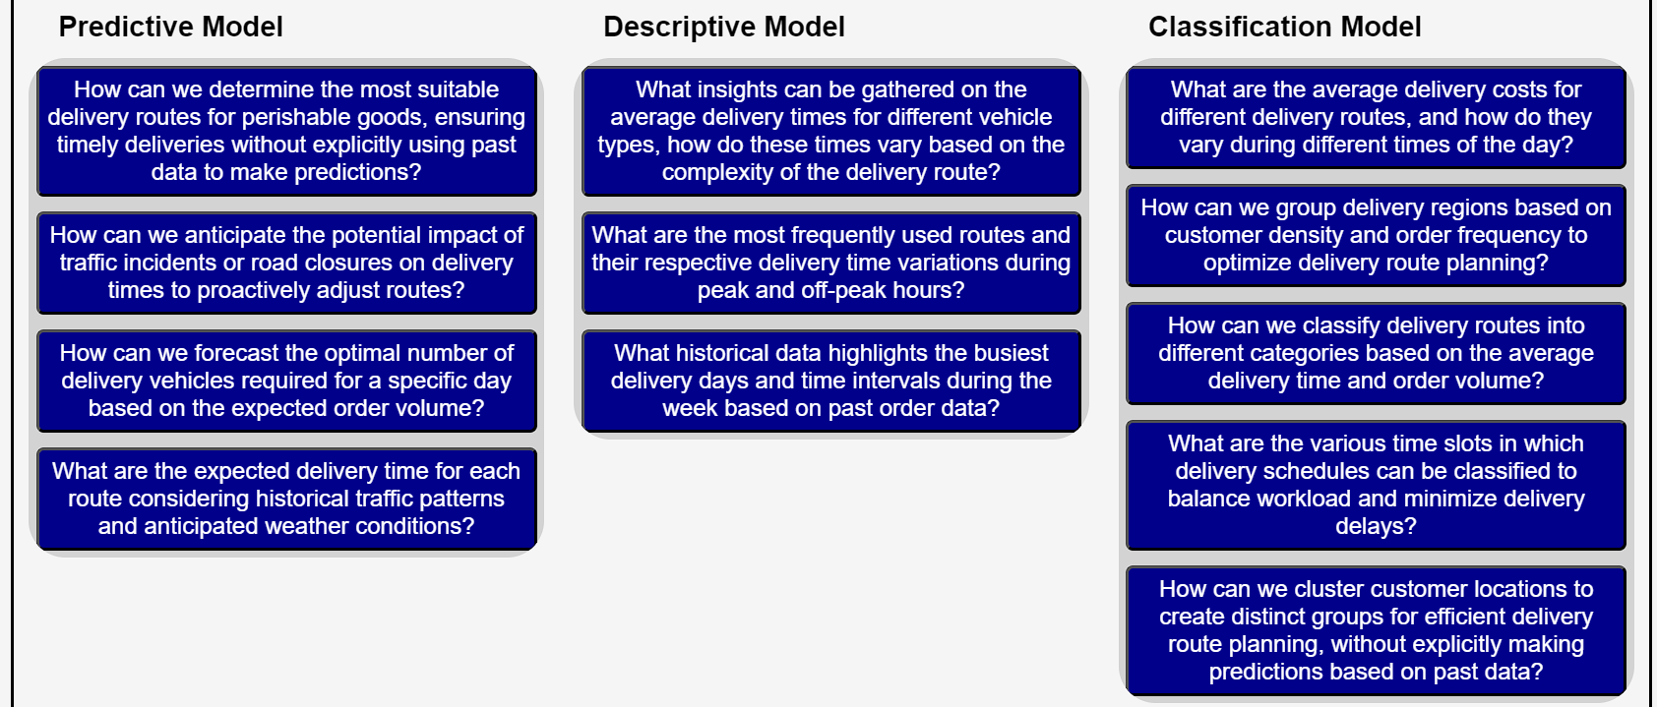

The "Data Requirements" phase in data science methodology involves defining the necessary data content, formats, and sources required to address the problem at hand. Here's an elaboration on the key points covered in the provided text:

1. **Analogy to Cooking**: The analogy of cooking with data is used to emphasize the importance of each step in the data science methodology. Just as missing ingredients can compromise a recipe**, incomplete or incorrect data can hinder the success of an analysis.**
2. **Identifying Data Requirements**: Similar to how a chef plans out the ingredients needed for a dish, data scientists identify the data requirements necessary to address the problem or question at hand**. This includes determining which data elements are required, where to source or collect them from, and how to work with them effectively.**

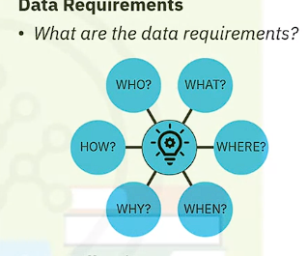

1. **Case Study Example**: In the provided case study, the data requirements were defined for a decision tree classification approach aimed at predicting patient readmission risk for congestive heart failure patients. The following steps were undertaken:
   1. **Patient Cohort Selection**: A suitable patient cohort was selected from the health insurance provider's member base based on specific criteria, including
      * admission within the service area,
      * primary diagnosis of congestive heart failure,
      * and continuous enrollment for at least six months prior to admission.
   * **Exclusion Criteria**: Patients with other significant medical conditions that could skew the results were excluded from the cohort.
   * **Data Content and Format**: The content, format, and representations of the data required for decision tree classification were defined. This included variables representing patient clinical history, such as admissions, diagnoses, procedures, prescriptions, and other services provided.
   * **Data Preparation**: To prepare the data for analysis, transactional records were rolled up to the patient level, creating new variables to represent relevant information.
2. **Anticipating Subsequent Stages**: Thinking ahead and anticipating the requirements of subsequent stages, such as data preparation, is important during the data requirements phase. This ensures that the data collected and formatted aligns with the analytical approach and desired outcome.
3. **Conclusion**: The "Data Requirements" phase lays the foundation for successful data collection and preparation by identifying the necessary data elements and formats required to address the problem effectively. By carefully defining data requirements, data scientists can ensure that the analysis aligns with business objectives and leads to meaningful insights and solutions.

Overall, understanding and defining data requirements is a critical step in the data science methodology, as it sets the stage for successful analysis and decision-making.

In the data science methodology, the data collection stage follows the initial data requirements phase. Here's a breakdown of the key points and considerations from the provided text:

1. **Assessment of Data Requirements:**
   * After the initial data collection, data scientists assess whether they have obtained all the necessary data or if there are gaps.
   * Decisions are made regarding whether more data is needed or if adjustments need to be made to the data requirements.
2. **Understanding Data Content and Quality:**
   * Techniques such as **descriptive statistics and visualization are applied to the collected data to assess its content, quality, and gain initial insights.**
   * **Gaps in the data are identified**, and plans are made **to fill them or make substitutions as necessary.**
3. **Source of Data Elements:**
   * Data collection requires knowing the sources or where to find the necessary data elements.
   * In the provided case study, examples of data elements needed include **demographic, clinical, and coverage information of patients, provider information, claims records, and pharmaceutical information related to congestive heart failure patients.**
4. **Deferred Decision on Unavailable Data:**
   * It's acceptable to defer decisions about unavailable data and attempt to acquire it at a later stage, even after obtaining intermediate results from predictive modeling.
   * If results suggest that missing data may be important, efforts can be invested to acquire it.
5. **Collaboration with DBAs and Programmers:**
   * Database administrators (DBAs) and programmers collaborate to extract data from various sources and merge it.
   * This collaboration allows for the removal of redundant data and prepares it for the next stage of the methodology, data understanding.
6. **Improving Data Management Processes:**
   * At the data understanding stage, discussions may occur among data scientists and analytics team members on ways to better manage data, including automating certain processes in the database to facilitate easier and faster data collection.

Overall, the data collection stage is crucial for obtaining the necessary data elements, assessing their quality, and preparing them for further analysis in subsequent stages of the data science methodology. Collaboration with relevant stakeholders and ongoing refinement of data management processes are essential for effective data collection and utilization.

**Data Understanding**

Let's delve deeper into each aspect of the data understanding stage in the data science methodology as outlined in the provided summary:

1. **Descriptive Statistics**:
   * Descriptive statistics involve calculating numerical summaries of the dataset to gain insights into its characteristics. Common statistics include measures of central tendency (such as mean and median), measures of dispersion (like standard deviation), and measures of distribution shape (such as skewness and kurtosis).
   * These statistics help in understanding the range and variability of each variable, providing a foundational understanding of the data's distribution and potential outliers.
2. **Pairwise Correlations**:
   * Pairwise correlations examine the relationships between pairs of variables in the dataset. This analysis is crucial for identifying associations and dependencies between variables.
   * Highly correlated variables may indicate redundancy, which can lead to issues such as multicollinearity in predictive modeling. Identifying and addressing such correlations is essential for model accuracy and interpretability.
3. **Histogram Analysis**:
   * Histograms visually represent the distribution of a variable by depicting the **frequency of values within predefined bins or intervals.**
   * Histograms offer insights into the shape, central tendency, and spread of the data. **They help in identifying potential data transformations or adjustments needed to meet modeling assumptions.**
   * For categorical variables with numerous distinct values**, histograms aid in understanding the distribution and may inform decisions on consolidating categories for improved model interpretability.**
4. **Data Quality Assessment**:
   * Data quality assessment involves **identifying and addressing issues such as missing values, outliers, inconsistencies, and inaccuracies in the dataset.**
   * Descriptive statistics and visualization techniques help in detecting missing values and understanding their implications. For instance, missing values may signify **actual absence, unknown information, or other meaningful categories.**
   * Addressing data quality issues is critical for **ensuring the reliability and validity of analyses and modeling results.**
5. **Iterative Process**:
   * The data understanding stage often necessitates iteration, where insights gained from initial analyses prompt revisiting earlier stages of the data science process, such as data collection or problem definition.
   * In the provided case study, refining the definition of congestive heart failure admissions based on insights from data understanding exemplifies the iterative nature of the methodology.
6. **Interactive Nature of Methodology**:
   * The data science methodology is depicted as an interactive and collaborative process involving continuous learning and refinement.
   * Through active engagement with both the problem domain and the data, data scientists iteratively improve their understanding, models, and solutions.
   * This iterative approach ultimately leads to the development of more accurate models and the derivation of meaningful insights to address complex problems effectively.

In summary, the data understanding stage serves as a crucial foundation for subsequent stages in the data science methodology. It involves thorough exploration, analysis, and interpretation of the dataset to gain insights into its characteristics, identify patterns, and inform subsequent modeling and analysis decisions.

1. **Data Preparation Importance**:
   * Data preparation is likened to washing vegetables, where unwanted elements are removed. Similarly, in data science, this phase involves **cleaning and transforming raw data to make it usable for analysis.**
   * It is emphasized that data preparation is a **time-consuming phase(70-90%)**, often taking up the majority of the project time. However, **automating certain processes can significantly reduce this time, allowing data scientists to focus more on modeling.**
2. **Data Transformation**:
   * Data transformation involves getting the data into a state that is **easier to work with**. This includes **addressing missing or invalid values, removing duplicates, and ensuring proper formatting.**
   * Just as chopping onions finer improves their **flavor distribution** in a sauce, transforming data improves its usability and effectiveness for analysis.
3. **Feature Engineering**:
   * Feature engineering is highlighted as a crucial aspect of data preparation. It involves using **domain knowledge to create new features** or variables that enhance the **performance of machine learning algorithms.**
   * Features are characteristics of the data **that influence the predictive models' outcomes. Proper feature engineering can significantly impact the results obtained from machine learning algorithms.**
4. **Text Analysis**:
   * When working with text data, additional steps such as text analysis are necessary. This involves coding the data to manipulate and analyze text effectively.
   * Text analysis ensures **proper grouping of text** elements and prevents **oversight of important information hidden within the text data.**
5. **Importance of Detail**:
   * The summary emphasizes the importance of attention to detail in the data preparation phase. Skipping over this phase or neglecting its importance can lead to subpar outcomes and may necessitate going back to the drawing board.
   * It underscores the analogy that just as one bad ingredient can ruin a meal, overlooking data preparation can compromise the quality and effectiveness of the data analysis.
6. **Defining Congestive Heart Failure (CHF)**:
   * Defining CHF precisely required identifying diagnosis-related group (DRG) codes **related to fluid buildup, considering that CHF is a type of heart failure**. Clinical guidance was crucial in **selecting the appropriate codes**.
7. **Defining Readmission Criteria**:
   * Determining criteria for CHF-related readmissions involved evaluating the timing of events. A 30-day window following discharge from the initial admission was set for **identifying relevant readmissions.**
8. **Aggregating Transactional Records**:
   * Transactional records, including claims and clinical data, were aggregated at the patient level. This process involved consolidating multiple records for each patient into **a single record, as required for subsequent modeling.**
9. **Feature Engineering**:
   * Many new columns were created during the aggregation process to represent **various aspects of patient history, such as frequency and recency of visits, diagnoses, procedures, prescriptions, and comorbidities (e.g., diabetes, hypertension).**
10. **Literature Review and Data Collection Iteration**:
    * A literature review on CHF was conducted to ensure important data elements, such as **additional comorbidities, were not overlooked**. This review prompted revisiting the data collection stage to include relevant indicators in the dataset.
11. **Merging Patient Data**:
    * Aggregated transactional data were merged with **demographic information at the patient level, including age, gender, and type of insurance**. This resulted in a comprehensive dataset with one record per patient and multiple attributes for modeling.
12. **Variable Selection**:
    * Variables ultimately used in building the predictive model included the dependent variable (CHF readmission within 30 days) and various independent variables representing patient demographics, clinical history, and comorbidities.
13. **Data Cohort Splitting**:
    * The dataset was split into training and testing sets for model building and validation purposes, respectively. This step ensures the model's generalizability and effectiveness in predicting CHF readmissions.